Activity 5.3: Same!
You need to create a program that checks if three numbers entered are the same. The program should:
- ask the user to enter three numbers and store each one in a variable
- check to see if all three numbers are the same. You will need to use and to compare the numbers
- if the numbers are the same, say All three numbers are the same
- otherwise say All three numbers aren’t the same.
For example:
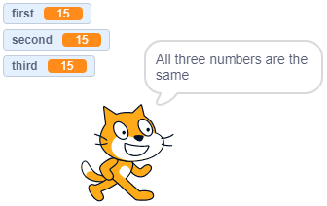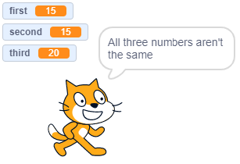

Don’t forget to screenshot your blocks and paste the screenshot into your evidence document.
Extension activity 1
Improve your program, so that if all three numbers are not the same, it checks to see if two are the same. To do this you will need to:
- add another if-else statement inside the else part of the first if-else statement
- check to see if any combination of two numbers is the same using or
- say Two numbers are the same if two numbers are the same
- say None of the numbers are the same if none of the numbers are the same.
For example:
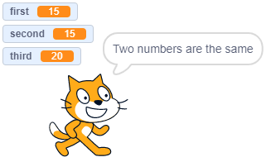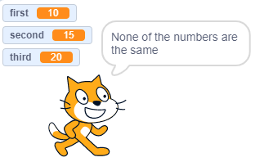
Remember to screenshot your blocks and paste the screenshot into your evidence document.
Extension activity 2
Improve your program further so that, if two numbers are the same, it will say which two numbers are the same. To do this you will need to:
- add another if-else statement inside the if-else statement that checks to see if any combination of two numbers is the same
- check to see if the first and second numbers are the same and, if they are, say The first and second numbers are the same
- if the first and second numbers are not the same, add another if-else statement to check if the second and third numbers are the same and, if they are, say The second and third numbers are the same
- if the second and third numbers are not the same, say The first and third numbers are the same.
For example:
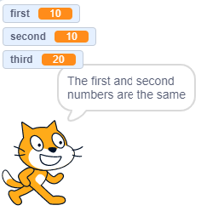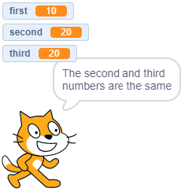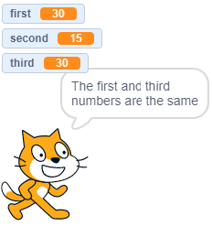
Remember to screenshot your blocks and paste the screenshot into your evidence document.

